Lesson plan
Unit 11 | Lesson: 31 | Every day I …

Teacher : Mrs Jawadi Samia


Date : Thursday , 8th May,‏ 2008‏‏ Classes: 6th form D / C G¹ /G ²‏
Monday, 12th May, ‏ 2008 Classes : 6th form B / A G¹ / G² ‏
Objectives:
By the end of this lesson pupils should be able to:
- Stating personal routine activities
New language:

Vocabulary : every/to get up /to wash /to comb / to wear / to brush / to take /to drink
Structures: The present simple
Pronunciation: Vowels in minimal pairs
Teaching aids :
A tape recorder / pictures

Stage | Procedures | Time
Warming – up | Teacher asks different pupils to say the last song  Teacher asks pupils to take their slates and invites them to write some words : sofa – carpet – bed – fridge – cooker (dictation) | 10mn
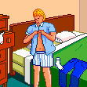
Presentation | Teacher presents a picture then she asks:  What do you do every day before going to school?  Pupils try then teacher introduces :  I get up early.  I wash my face.  I comb my hear.  I wear my clothes.  I take my breakfast.  I brush my teeth.  Pupils use new words in sentences  Teacher asks pupils about their daily activities and makes them making a sentence using the new words. | 25mn
Practice | 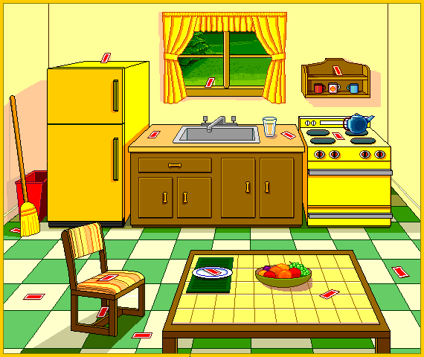  Teacher invites pupils to open their books at page158  Teacher reads the text.  Pupils follow on their books.  Then pupils read the text.  Teacher plays the cassette twice. Pupils listen and follow on their books.  Pupils repeat.  Teacher asks pupils to read then do the activities on page 160/161  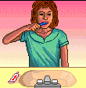  Then check and correct     | 25mn

