Pioneer Prep School - Sfax  School year: 2023/2024  End term test N°1  in Computer Science | Teacher: Mr. Abdelkarim BEN AYED
 | Classes: 8b 8
 | Date: Monday 04/12/2023 Duration: 50 minutes

Name & Surname: ………………………………………………….Class:…………PC N°:…… | Mark :…………… /20
- Create your test folder “Test1 name surname class” in your folder in disk D.
- Create a new project “Password rules” then save the it in your test folder using Scratch (you can also use a Video editing software).
- Insert in order the following backdrops in your project using images from the web (Save the used images in your test folder).
Complete backdrops 2, 3, 4 and 5 with appropriate texts.
Password rules  Created by Name Surname Class | Rule 1  … …   | Rule 2  … …  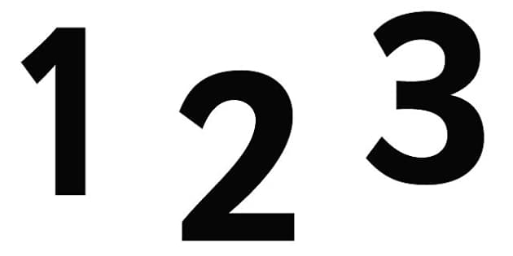 | Rule 3  … …   | Rule 4  … …  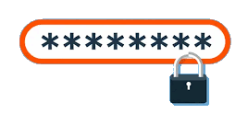 | The END
Backdrops 1 (5s) 2 (5s) 3 (5s) 4 (5s) 5 (5s) 6
- The duration is 5 seconds for each backdrop.
- Use clearly presentable colors and fonts for texts of your choice.
- Save the modifications. (Export to MP4 format if using video editing).
 Notes:
- Remember to save your work regularly.
Marking Scale (pts) | 1) | 2) | 3) | 4) | 5) | 6)
Marking Scale (pts) | 1 | 1 | 12 | 2 | 2 | 2

