Lesson plan
Unit 10 | Lesson: 30 | What’s my family doing?

Teacher : Mrs Jawadi Samia

Date : Monday , 20th April,‏ 2008‏‏ Classes: 6th form B / A G¹ /G ²‏
Tuesday, 21^{rst} April, ‏ 2008 Classes : 6th form D / C G¹ / G² ‏
Objectives:
By the end of this lesson pupils should be able to:
- Talking about home activities
New language:
Vocabulary : to do / to drink / newspaper / home / milk
Structures: What’s ……. doing ?
Pronunciation: Vowels in minimal pairs
Teaching aids :
A tape recorder / pictures

Stage | Procedures | Time
Warming – up | Teacher asks different pupils to say the last dialogue  Teacher asks pupils to take their slates and invites them to write some words : sofa – carpet – bed – fridge – cooker (dictation) | 10mn

Presentation | Teacher presents a picture then she introduces:  Where’s mum? Dad?  What’s dad doing? / What’s mum doing?  Pupils answer and use new structures in sentences  He’s in the living-room. He’s reading a newspaper.  Teacher asks pupils about their family activities and makes them making a sentence using the new structure. | 25mn
Practice | 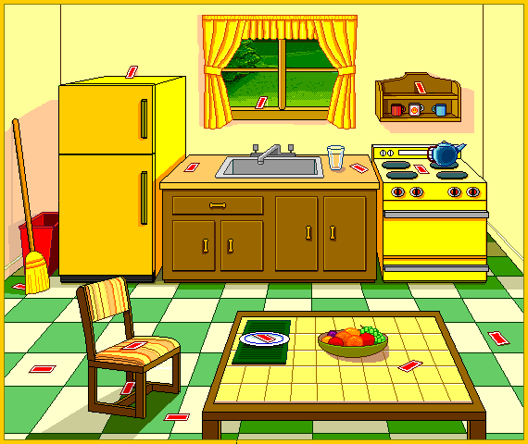  Teacher invites pupils to open their books at page154  Teacher read the SMS on page 155  Pupils follow on their books.  Then pupils write their one SMS  Pupils do the activities  Then check and correct | 25mn

