Lesson plan
Unit 11 | Lesson: 32 | My day

Teacher : Mrs Jawadi Samia
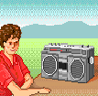
Date : Tuesday , 13th May,‏ 2008‏‏ Classes: 6th form D / C G¹ /G ²‏
Wednesday, 14th May, ‏ 2008 Classes : 6th form B / A G¹ / G² ‏
Objectives:
By the end of this lesson pupils should be able to:
- Talking about daily activities at different moment of the day.
New language:
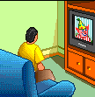
Vocabulary : morning – afternoon – evening – night – dinner Structures: In – at + period of a day
Pronunciation: Vowels in minimal pairs
Teaching aids :
A tape recorder / pictures

Stage | Procedures | Time
Warming – up | Teacher asks different pupils to say the last song ( This is the way )  Teacher asks pupils to take their slates and invites them to write some words : I brush my teeth every night – I comb my hear - I wear my clothes (dictation) | 10mn
resentation |  Teacher presents a picture of a clock then she asks:  What do you do at this moment of the day?  Pupils try then teacher introduces :  I have my breakfast in the morning at seven o’ clock in the kitchen .  I drink my coffee in the morning in the kitchen.    I have my dinner at the evening at night .  I wear my clothes in my room .  I brush my teeth with a brush in the bathroom.  I play sport and listen to music in the afternoon.  Pupils use new words in sentences while looking at the pictures.  Teacher asks pupils about their daily activities and makes them making a sentence using the new words.  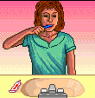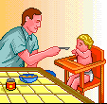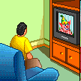 | 25mn
Practice | 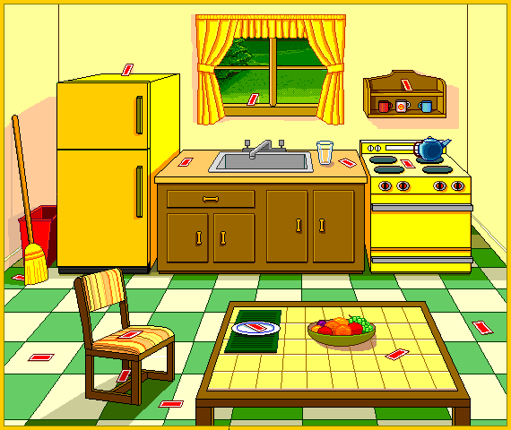  Teacher invites pupils to open their books at page163  Teacher reads .  Pupils follow on their books.  Then pupils read the text.  Teacher asks pupils to read then do the activities on page 164/165  Then check and correct | 25mn

