|  |  |  |
| --- | --- | --- |
| **Schoolname**  **……………………………….**  **5th grade** | **FIRST TERM EXAM**  **2022/2023** | **PupilName**  ……………………………….  ………..……..……………… |

**Dictation : (6 marks)**

1. **Listen and write the words : (3 marks)**

……................... …………………….…. ……….….…………..

1. **Listen and write the missing words : (3marks)**

* Mary is ……………………… a red ……………………… , a brown coat, and……………………… trousers.

**Spelling : (6 marks)**

1. **Reorder the scramled letters to label pictures : (3 marks)**

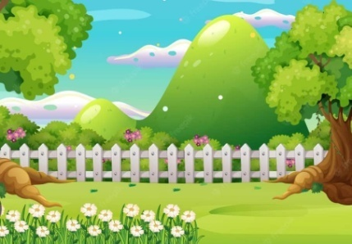

r/e/d/n/g/a a/m/i/l/f/y k/a/b/r/e

……………………………………… ………………………………………. …………………………………………….

1. **Match word parts : (3 Marks)**

Kit * *bours

Hand * *chen

Neigh* *some

**Language : ( 8 Marks)**

1. **Circle the right alternative : (3 marks)**

* This is my friend Ahmed. (**He/ She/We**) is 10. The boy likes ( **listening/ reading/**

**singing**) books. We sometimes (**dance/play/draw**) football in the park.

1. **Match the pictures with expressions : ( 3 marks)**

 Practice sport

 Write on the board

 Read a book

**3)Complete the paragraph with words from the box.**

**There is an extra word. (2 marks)**

|  |
| --- |
| **are/ park/is** |

* Helen goes to the…………………... . She ………………… playing hopscotch.